Kansas Virtual Education Requirements and Monitoring Plan

Kansas leads the world in the success of each student.
Edited August 2021

KANSAS VIRTUAL EDUCATION REQUIREMENTS AND MONITORING PLAN
Contents
Kansas Virtual Education Overview 1
New Virtual School and Program Approval Process 3
Returning Virtual School And Program Renewal Process 4
Returning Virtual Multi-Year, Risk-Based Monitoring Plan 5
Multiyear, Risk-Based Monitoring Plan Diagram 5
Risk Factors 6
Multiyear Monitoring Cycle Cohorts 7
Personnel Requirements 8
Program Director 8
Teaching Staff 9
Counseling Staff 9
Program Requirements 10
Enrollment and Funding 10
Attendance and Truancy 11
Courses, Credits and Assessments 11
Communication with Student and Families 12
Student Involvement and Support Services 12
Professional Development 13
Recruitment and Advertising 13
School Improvement and Accreditation 13

Adopted by Kansas State Board of Education, April 19, 2016 Revised July, 2020

Kansas Virtual Education Overview
Per Kansas Statute 72-3712, a virtual school or program:
- Is offered for credit.
- Uses distance learning technologies which predominately use internet-based methods to deliver instruction.
- Involves instruction that occurs asynchronously with the teacher and pupil in separate locations.
- Requires the pupil to make academic progress toward the next grade level and matriculation from kindergarten through high school graduation.
- Requires the pupil to demonstrate competence in subject matter for each class or subject in which the pupil is enrolled as part of the virtual school.
- Requires age-appropriate pupils to complete state assessment tests.

Per the Kansas State Department of Education (KSDE), a virtual school or program:
- Meets the definition in Kansas statute 72-3712.
- Meets the virtual education requirements outlined in this document.
- Offers a full-time or part-time virtual education to students.
- Receives approval during its multi-year performance portfolio monitoring.
The only difference between a virtual school and a virtual program is that a school has its own building number for data reporting and a program uses another school’s building number for data reporting. In all other ways, they are the same, and both must adhere to these virtual requirements.

K ANSAS VIRTUAL EDUCATION OVERVIEW
KANSAS VIRTUAL EDUCATION REQUIREMENTS AND MONITORING PLAN

Each district may operate an unlimited number of virtual schools and programs, so long as there is no overlap of grade levels in each. For instance, a district may operate a K-6 virtual school and a 7-12 virtual school but may not operate a 9-12 virtual school and 7-12 virtual school. A district may also choose to contract with a service center for the operation of a virtual program or a diploma completion program. The grade levels in the service center, operated program and a district’s own virtual school or program may overlap. For instance, the district may operate a K-12 virtual school and contract with the service center for a 9-12 diploma completion program.

The following schools and programs WILL The following schools and programs WILL
be covered under these requirements: NOT be covered under these requirements

- District-operated virtual schools and programs.
- District-operated diploma completion programs that use a virtual model.
- District contracts with service centers for individual virtual programs.
- District contracts with service centers for diploma completion programs that use a virtual model.
and instead will fall under the Diploma Completion Program Requirements:
- District-operated diploma completion programs that use an alternative model.
- District contracts with service centers for diploma completion programs that use an alternative model.

New Virtual School and Program Approval Process
Timeline of activities to become an approved virtual school or program:
  - Submit New Virtual Intent Form to KSDE by the second Friday in February
  - Participate in new virtual training opportunities in March
  - Participate in New Virtual Performance Portfolio Monitoring in April:
    - Schedule new virtual monitoring conference call date
    - Complete Virtual Demographics Form
    - Complete Virtual District Assurances
    - Complete New Virtual Narrative Form
    - Develop virtual student handbook, assurances, rights and responsibilities
    - Submit all required documentations to KSDE at least one week prior to monitoring conference call date
    - Participate in new virtual monitoring conference call
    - Respond to any findings outlined in the Virtual Findings Letter within 30 days,
if applicable
  - Receive approval to operate new virtual school or program.

KSDE will also partner new virtual directors with an existing virtual director to serve as
a mentor throughout the first year.

Returning Virtual School And Program Renewal Process
Timeline of activities to remain an approved virtual school or program:
- Complete Annual Progress Review every January:
  - Complete Virtual Demographics Form
  - Complete Virtual District Assurances
  - Complete Virtual Professional Development Report
- Participate in Virtual Performance Portfolio Monitoring in February/March/April (once every three years, unless risk factors identified in Annual Progress Review call for automatic monitoring that year):
  - Schedule virtual monitoring conference call date
  - Complete Returning Virtual Narrative Form
  - Update virtual student handbook/assurances/rights and responsibilities*
  - Submit documentation to KSDE at least one week prior to monitoring conference call date
  - Participate in virtual monitoring conference call
  - Respond to any findings outlined in the Virtual Findings Letter within 30 days, if
applicable
- Receive approval to operate virtual school or program for an additional three years

*Recommended, but not required.

KANSAS VIRTUAL EDUCATION REQUIREMENTS AND MONITORING PLAN

Returning Virtual Multi-Year, Risk-Based Monitoring Plan

Multi-Year, Risk-Based Monitoring Plan Diagram

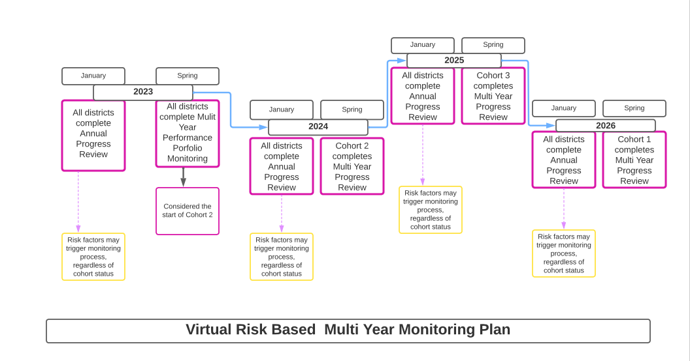

RETURNING VIRTUAL MULTI-YEAR RISK-BASED MONITORING PLAN
K ANSAS VIRTUAL EDUCATION REQUIREMENTS AND MONITORING PLAN

Risk Factors
If a virtual school or program has a new virtual director identified on the Annual Progress Review, the school or program will have automatic monitoring done that year; even if it is not its cohort year.
If a virtual school or program has two or more of the following risk factors identified on the Annual Progress Review, the school or program will have automatic monitoring done that year; even if it is not its cohort year.
If a virtual school or program has only one of the following risk factors identified on the Annual
Progress Review, the school or program will be invited to receive additional supports from KSDE.

Risk factors include:
- More than 50% licensed staff turnover.
- Change in online curriculum provider.
- Three or more monitoring findings from the previous year’s Performance Portfolio Monitoring.
- Persistently unresponsive to KSDE requests.
- Three or more complaints reported by students and/or their families.
- KSDE has the discretion to initiate monitoring in unique cases.
If a virtual school or program is pulled for automatic monitoring, the school or program will return to its original cohort cycle afterward. This may mean that a virtual school or program is monitored in back-to-back years.

RETURNING VIRTUAL MULTI-YEAR RISK-BASED MONITORING PLAN
K ANSAS VIRTUAL EDUCATION REQUIREMENTS AND MONITORING PLAN

Multi-Year Monitoring Cycle Cohorts
These cohorts match the Early Childhood and Special Education and Title Services Monitoring Cycle Cohorts.

Cohort 1 (2025)
- Buhler USD 313
- Centre USD 397
- Coffeyville USD 445
- Colby USD 315
- Derby USD 260
- De Soto USD 232
- Eudora USD 491
- Educational Services and Staff Development Association of Central Kansas (ESSDACK)
- Leavenworth USD 453
- Hutchinson USD 308
- Independence USD 446
- Nickerson USD 309
- Ottawa USD 290
- Pratt USD 382
- Riverside USD 114
- Smoky Valley USD 400
- South Haven USD 509
- South Lyon County USD 252
- Technology Excellence Education Network (TEEN) Interlocal 632
- Topeka USD 501
- Wellington USD 353
- Wichita USD 259
- Winfield USD 465

Cohort 2 (2023)
- Abilene USD 435
- Andover USD 385
- El Dorado USD 490
- Garden City USD 457
- Goodland USD 352
- Haven USD 312
- Hays USD 489
- Holcomb USD 363
- Hugoton USD 210
- Humboldt USD 258
- Kingman-Norwich USD 331
- Kiowa County USD 422
- Labette County USD 506
- Maize USD 266
- Manhattan-Ogden USD 383
- McPherson USD 418
- Olathe USD 233
- Otis-Bison USD 403
- Spring Hill USD 230
- Udall USD 463
- Ulysses USD 214

Cohort 3 (2024)
- Basehor-Linwood USD 458
- Caldwell USD 360
- Central Plains USD 112
- Chapparal USD 361
- Clay Center USD 379
- Elkhart USD 218
- Flint Hills USD 492
- Fort Scott USD 234
- Fredonia USD 484
- Lawrence USD 497
- Montezuma USD 371
- Newton USD 373
- Oxford USD 358
- Piper USD 203
- Salina USD 305
- South Central Kansas Special Education Cooperative (SCKSEC) Interlocal 628
- Smoky Hill USD 629
- South Barber USD 255

Personnel Requirements

Program Director
The program director must be licensed/certified in Kansas. The local board of education may establish the type of licensure/certification required for the position. KSDE considers this person responsible for the day-to-day operation of the program and will use them as the primary point of contact for all correspondence related to the virtual school/program.
The program director is also responsible for coordinating the following services:
  - Student/family communication: Ensure ongoing and continuous communication
occurs among schools, teachers, students, families, and other virtual staff members.
  - Technical support: Support all technical aspects of the virtual school or program, ensure student's opportunity to learn is not hindered because of technical problems and communicate technology back-up plan to the parents/students during the enrollment process.
  - Professional development: Develop, implement and evaluate training provided to
all staff, students and parents in the use of the on-line system.
  - Assessments: Ensure that grade-level virtual students participate in all district and state assessments.
  - Data entry: Provide data entry services for course creation, enrollment of students in virtual courses, and processing of student grades for report cards and transcripts.

Teaching Staff
PERSONNEL REQUIREMENTS
KANSAS VIRTUAL EDUCATION REQUIREMENTS AND MONITORING PLAN

The school/program must utilize teachers that are licensed by the state of Kansas in providing instruction AND/OR have monitors that are licensed by the state of Kansas providing oversight of students and content. If virtual course monitors are employed, the student must have access to Kansas-licensed and certified-content teachers to answer content specific questions for every core subject the student is enrolled in. The virtual course monitor may answer questions for elective subjects the student is enrolled in. Teachers and virtual course monitors for adult students should be licensed at the secondary level. All virtual staff members are expected to provide responses to students and families within a 24-hour turnaround during school days.
Virtual teacher: Provides direct instruction Virtual course monitors: Monitors virtual to virtual students and/or grades content students in an online curriculum that provides specific assignments. the instruction and automatically grades

- Must be licensed and certified in the appropriate content area by the state and
assignments or provides rubric for monitors to grade assignments.

at the appropriate elementary, middle or • Must be licensed at the appropriate secondary level. elementary, middle or secondary level
by the state.

The virtual school or program may also employ teaching assistants/paraprofessionals to assist with small-group instruction designed by the teacher, tutoring, communication outreach with students and families, technology issues and test proctoring.

Counseling Staff
The services of a Kansas-licensed counselor must be made available to all virtual students. This may be done virtually or in a face-to-face setting.

Program Requirements

Enrollment and Funding

Virtual Students 19 and Younger
Virtual students must attend at least two days in order to be included in the district’s virtual enrollment count. Students must attend a minimum of one day on or before Sept.19 AND a single day on or after Sept. 20, but on or before Oct. 4.
In order to fulfill the “attending” provisions within a virtual school or program, the student may attend in two ways. On a given day, a student’s minutes may consist of multiple ways of attending. The school or program is responsible for providing to the fiscal auditor documentation for the two days the district wishes to count for each student’s “Minutes Enrolled.”

- Online: Time should be a documented from the virtual school or program’s computer system showing when the student was connected to the online curriculum.
- Offline: Time should be documented with an Academic Activity Log. This log should show the student’s name, date of attendance, classes attended and the amount of time the student was working off-line completing course requirements.

Once the student has fulfilled the two-day attendance rule above, to compute minutes enrolled, find the longest day the student attended (limited to 360 minutes) on any day on or before Sept. 19 and the longest day the student attended (limited to 360 minutes) on or after Sept. 20, but on or before Oct. 4. Add the two numbers together, and divide by 2, rounded to a whole minute.

PROGRAM REQUIREMENTS
KANSAS VIRTUAL EDUCATION REQUIREMENTS AND MONITORING PLAN

Virtual Students 20 and Older
Virtual students 20 and older will not be funded on minutes enrolled on the count days and are not required to be “enrolled and attending” within the two separate count windows. Rather, any credits earned by virtual students 20 and older between July 1 and June 30 will be funded at $709 per credit hour.
Virtual students 20 and older must also have a district enrollment form, transcript analysis, individual graduation plan and be enrolled in high school credit earning courses.
See the current enrollment handbook for a comprehensive outline of requirements:
https://www.ksde.org/Portals/0/Auditing/Enrollment%20Handbook%20FY22.pdf? ver=2021-08-26-095355-947

Attendance and Truancy
Virtual students under 18 are subject to the requirements of compulsory attendance (K.S.A. 72-1111) and truancy (K.S.A. 72-1113). Virtual schools and programs should modify these statutes to apply to a week of school, rather than a day of school and should include their own progress expectations.

Courses, Credits and Assessments
Goals and objectives for all online courses must be correlated to local, state and/or national standards to ensure quality in content. Students and parents must be provided access to the standards being taught within each online course, upon request.
Syllabus information (outlines, materials lists, communication expectations, grading policies and grading formats) and assignment completion timelines or target dates must be provided for each online course.
Students must be awarded credit when they have met all goals and objectives for each online course and demonstrated competence.
Credits must be reported to the district for immediate entry onto the student’s transcript at the end of each semester.
Virtual schools/programs are responsible for delivering state assessments when applicable to the students’ assessment windows. These assessments will be conducted under the same conditions as assessments delivered to brick-and-mortar students (i.e., proctoring and special- needs support).

PROGRAM REQUIREMENTS
KANSAS VIRTUAL EDUCATION REQUIREMENTS AND MONITORING PLAN

Communication with Student and Families
Virtual staff will communicate with students on a weekly basis at a minimum to ensure
quality education is being provided.
Required communication includes, but is not limited to:
  - Orientation sessions.
  - Feedback on performance before final course grades are awarded.
  - Responses to student and parent questions within a 24-hour turnaround during school days.
  - Formal conferences each semester and as often as necessary.
A comprehensive communication plan should be in place to address the needs of the students. This plan should also identify a method of communication for when the students’ direct teacher/monitor is not available.

Student Involvement and Support Services
Opportunities for students to engage in interactive activities must be provided (e.g., field trips, district activities, study sessions, chat groups, video conferencing, online clubs, onsite celebrations and face-to-face instruction).
Students and families must be provided an academic/activity calendar for the virtual school or program.
Communication opportunities must be provided that enable students to share with others (e.g., discussion boards, chats, virtual classrooms, emails, group online projects and roundtable discussions).
A district policy, that aligns with federal law, must be established for the provision of special education, English for Speakers of Other Languages (ESOL), migrant and homeless services for virtual students.
Student intervention plans must be developed for virtual students, as needed, to address attendance and academic issues.

Professional Development
PROGRAM REQUIREMENTS
KANSAS VIRTUAL EDUCATION REQUIREMENTS AND MONITORING PLAN

All staff involved with the virtual school or program must receive professional development that is appropriate for their job responsibilities, as determined by district. Professional development should be documented per district processes.
Required topics include, but are not limited to:
  - Online pedagogy.
  - Communication, classroom management and student engagement strategies in a virtual setting.
  - Using the e-Learning system, as well as any other hardware/software required.
Per state statute, each year the district must submit a report highlighting the professional development provided to teachers who teach in virtual schools and programs. KSDE will collect this information as part of the Annual Progress Review.

Recruitment and Advertising
Virtual schools and programs that accept out-of-district students must provide KSDE with a link to their virtual school or program website, if one exists, by July 1. The district that
is associated with the virtual school or program must be prominently displayed on the website homepage.
Virtual schools and programs may engage in the following types of advertising: newspaper, radio, billboards, television, flyers and mailings.
Virtual schools and programs that plan to advertise in-person, in another district, must notify the superintendent of that district at least one week in advance of the event. This notification may be done via email, letter or phone call. This is a courtesy notification, not a request for permission.

School Improvement and Accreditation
Virtual schools and programs must be integrated into the district’s strategic plan and included in district policies.
Virtual schools and programs must adhere to all relevant state statutes, regulations and requirements.
Virtual schools and programs must report all data as required by KSDE, including Kansas Individual Data on Students (KIDS) records (ASGT, ENRL, EXIT, EOYA, TEST and STCO).

KANSAS STATE BOARD OF EDUCATION

CHAIRMAN
DISTRICT 9
VICE CHAIR
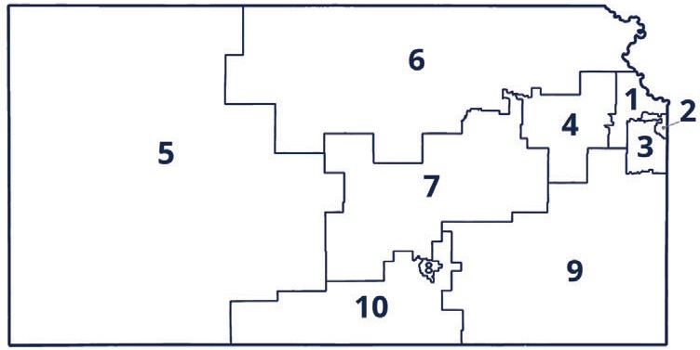
DISTRICT 1

MISSION
To prepare Kansas students for lifelong success through rigorous, quality academic instruction, career training and character development according to each student’s gifts and talents.

VISION
Kansas leads the world in the success of each student.

MOTTO
Kansans Can

SUCCESS DEFINED
A successful Kansas high school graduate has the
- Academic preparation,
- Cognitive preparation,
- Technical skills,
- Employability skills and
- Civic engagement
to be successful in postsecondary education, in the attainment of an industry recognized certification or in the workforce, without the

Jim Porter
jporter@ksde.org

DISTRICT 2

Melanie Haas
mhaas@ksde.org

LEGISLATIVE LIAISON
DISTRICT 6

Dr. Deena Horst
dhorst@ksde.org

Janet Waugh
jwaugh@ksde.org

DISTRICT 3

Michelle Dombrosky
mdombrosky@ksde.org

LEGISLATIVE LIAISON
DISTRICT 7

Ben Jones
bjones@ksde.org

DISTRICT 4

Ann E. Mah
amah@ksde.org

DISTRICT 8

Betty Arnold
barnold@ksde.org

DISTRICT 5

Jean Clifford
jclifford@ksde.org

DISTRICT 10

Jim McNiece
jmcniece@ksde.org

need for remediation.
KANSAS STATE DEPARTMENT OF EDUCATION

OUTCOMES
- Social-emotional growth measured locally
- Kindergarten readiness
- Individual Plan of Study focused on career interest
- High school graduation
- Postsecondary success
COMMISSIONER OF EDUCATION

Dr. Randy Watson
DEPUTY COMMISSIONER
Division of Fiscal and Administrative Services

Dr. S. Craig Neuenswander
DEPUTY COMMISSIONER
Division of Learning Services

Dr. Brad Neuenswander

900 S.W. Jackson Street, Suite 600
Topeka, Kansas 66612-1212
(785) 296-3203
www.ksde.org
The Kansas State Board of Education does not discriminate on the basis of race, color, national origin, sex, disability or age in its programs and activities and provides equal access to any group officially affiliated with the Boy Scouts of America and other designated youth groups. The following person has been designated to handle inquiries regarding the nondiscrimination policies: KSDE General Counsel, Office of General Counsel, KSDE, Landon State Office Building, 900 S.W. Jackson, Suite 102, Topeka, KS 66612, (785) 296-3201.
April 27, 2021

For more information, contact:
Dr. David Fernkopf
Assistant Director
Career, Standards and Assessment Services

Kansas State Department of Education 900 S.W. Jackson Street, Suite 102
Topeka, Kansas 66612-1212

(785) 296-8447
www.ksde.org
dfernkopf@ksde.org

